SQL ASSIGNMENT 15

1) Question

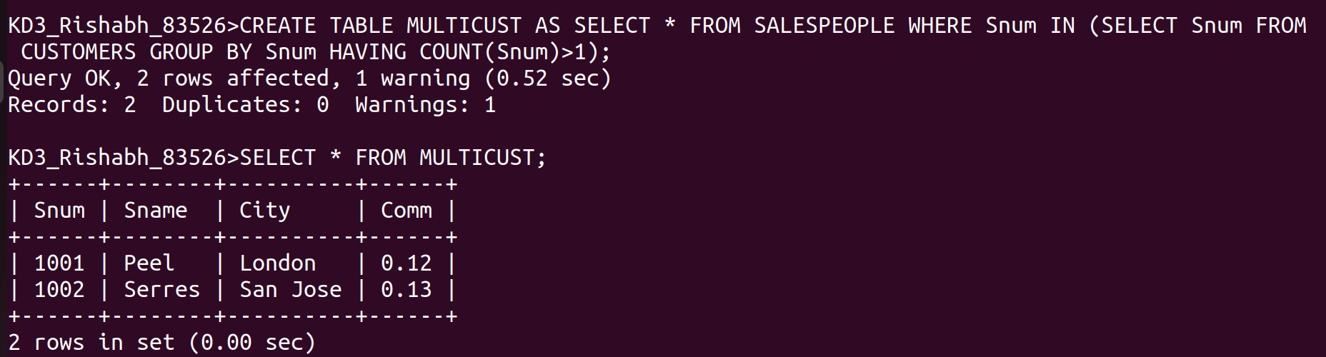
2) Question

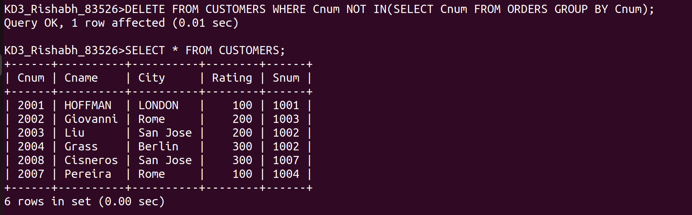
3) Question

